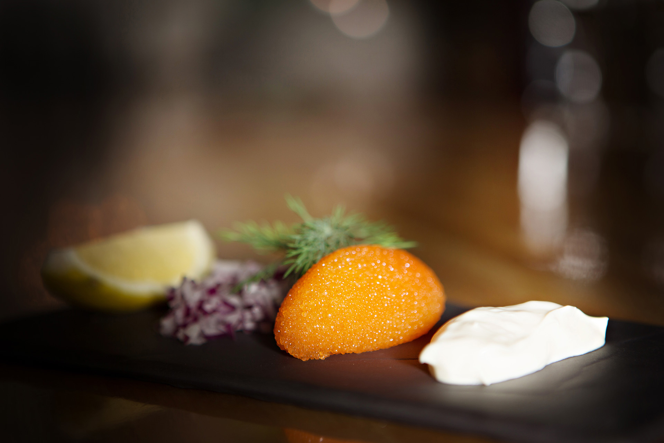

strap line

Flavors of the Arctic from the Forest, Lake and Ocean

Restaurant

Rooted in local products and traditions our culinary philosophy is inspired the best flavours of Swedish Lapland and delivered in a welcoming and beautiful setting.
Nordic gastronomy is today the very focus of attention for the international food media. Sweden, along with the other Nordic countries, offers a refuge of clean, unspoiled nature, producing the very best of ingredients.

Great sourcing is central to our philosophy. Our team of local talented chefs offer a food menu that changes every day depending on the products that are in season and available at that time of the year.
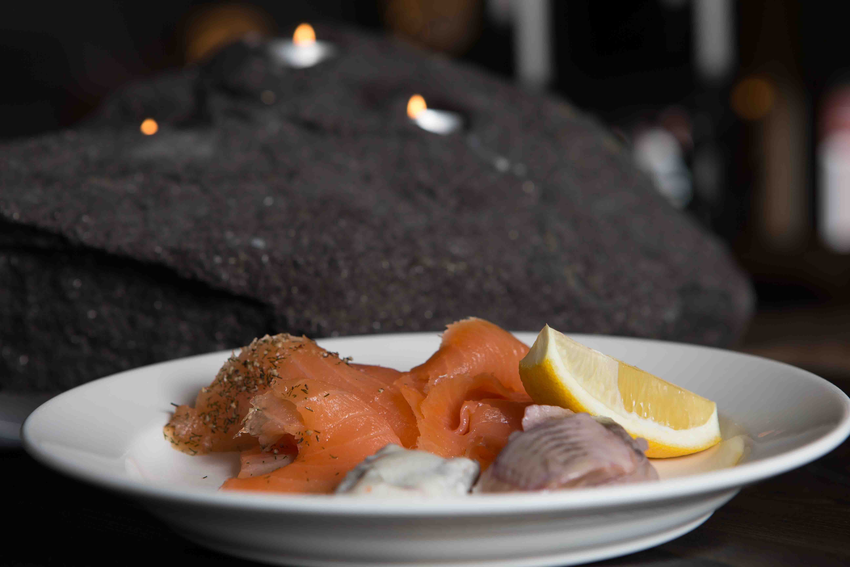
Our food is focused, contemporary and simple. Head Chef, Magnus Nordstrom will find game from the northern forests and fells as well as fish and seafood from lakes of Lapland and the Arctic Ocean. Wild berries, herbs and vegetables also play an important role and add authentic taste to meat and fish. We use seasonal ingredients, so our menu changes by the season

